**Project Name** : Weather Forecast App

**Roll Number** : 2102901520055

**Name** : ISHIKA JAIN

**Branch** : CSE – AI

**Section** : A

File Name : main.py

Source Code :

from tkinter import *

import tkinter as tk

from geopy.geocoders import Nominatim

from tkinter import ttk,messagebox

# noinspection PyUnresolvedReferences

from timezonefinder import TimezoneFinder

from datetime import datetime

import requests

import pytz

root = Tk()

root.title("weather App")

root.geometry("900x500+300+200")   #set the size of the window screen

root.resizable(False,False)

#getweather function

def getWeather():

    try:

        city=textfield.get()

        '''geolocator = Nominatim(user_agent="geoapiExercises")

        location = geolocator.geocode(city)

        obj = TimezoneFinder()

        result = obj.timezone_at(lng=location.longitude,lat=location.latitude)

        home = pytz.timezone(result)

        local_time = datetime.now(home)

        current_time = local_time.strftime("%I:%M:%p")

        clock.config(text=current_time)

        name.config(text="CURRENT WEATHER")

        '''

        #weather

        api="https://api.openweathermap.org/data/2.5/weather?q="+city+"&appid=28d00a96f0a71f650ed38d49d98e5b79"

        json_data = requests.get(api).json()

        condition = json_data['weather'][0]['main']

        description = json_data['weather'][0]['description']

        temp = int(json_data['main']['temp']-273.15)

        pressure = json_data['main']['pressure']

        humidity = json_data['main']['humidity']

        wind = json_data['wind']['speed']

        t.config(text=(temp,"°"))

        c.config(text=(condition,"|","FEELS","LIKE",temp,"°"))

        w.config(text=wind)

        h.config(text=humidity)

        d.config(text=description)

        p.config(text=pressure)

    except Exception as e:

        messagebox.showerror("Weather App","Invalid Entry!!")

#SEARCH BOX

Search_image=PhotoImage(file="search.png")

myimage=Label(image=Search_image)

myimage.place(x=20,y=20)                        #search image location

list_name=["Andhra Pradesh","Arunachal Pradesh ","Assam","Bihar","Chhattisgarh","Goa","Gujarat","Haryana","Himachal Pradesh","Jammu and Kashmir","Jharkhand","Karnataka","Kerala","Madhya Pradesh","Maharashtra","Manipur","Meghalaya","Mizoram","Nagaland","Odisha","Punjab","Rajasthan","Sikkim","Tamil Nadu","Telangana","Tripura","Uttar Pradesh","Uttarakhand","West Bengal","Andaman and Nicobar Islands","Chandigarh","Dadra and Nagar Haveli","Daman and Diu","Lakshadweep","National Capital Territory of Delhi","Puducherry"]

sc=ttk.Combobox(root,text="list_name",values=list_name,font=("time new roman",30,"bold"))

sc.place(x=500,y=20,width=150)

#textfield

textfield=tk.Entry(root,justify="center",width=17,font=("poppins",25,"bold"),bg="#404040",border=0,fg="white")         #font of textfield

textfield.place(x=50,y=40)                      #location of searchfield

textfield.focus()                                #for showing cursor in text field

#search_icon   #button

search_icon=PhotoImage(file="search_icon.png")

myimage_icon=Button(image=search_icon,borderwidth=0,cursor="hand2",bg="#404040",command=getWeather)             #@@@@@@@@@@@@@@@@@@@@@@@@@@22222

myimage_icon.place(x=400,y=34)

#LOGO

Logo_image=PhotoImage(file="logo.png")

logo=Label(image=Logo_image)

logo.place(x=150,y=100)

#Bottom box

Frame_image=PhotoImage(file="box.png")

frame_myimage=Label(image=Frame_image)

frame_myimage.pack(padx=5,pady=5,side=BOTTOM)

#TIME

name=Label(root,font=("arial",15,"bold"))

name.place(x=30,y=100)

clock=Label(root,font=("Helvetica",20))

clock.place(x=30,y=130)

#label

label1=Label(root,text="WIND",font=("Helvetica",15,'bold'),fg="#1ab5ef")   #fg='white',bg='#1ab5ef'

label1.place(x=120,y=400)

label2=Label(root,text="HUMIDITY",font=("Helvetica",15,'bold'),fg="#1ab5ef")

label2.place(x=250,y=400)

label3=Label(root,text="DESCRIPTION",font=("Helvetica",15,'bold'),fg="#1ab5ef")

label3.place(x=430,y=400)

label4=Label(root,text="PRESSURE",font=("Helvetica",15,'bold'),fg="#1ab5ef")

label4.place(x=650,y=400)

t=Label(font=("arial",70,"bold"),fg="#ee666d")

t.place(x=400,y=150)

c=Label(font=("arial",15,"bold"))

c.place(x=400,y=250)

w=Label(text="...",font=("arial",20,"bold"),bg="#1ab5ef")

w.place(x=120,y=430)

h=Label(text="...",font=("arial",20,"bold"),bg="#1ab5ef")

h.place(x=280,y=430)

d=Label(text="...",font=("arial",20,"bold"),bg="#1ab5ef")

d.place(x=450,y=430)

p=Label(text="...",font=("arial",20,"bold"),bg="#1ab5ef")

p.place(x=670,y=430)

root.mainloop()

Screenshots of Projects :-

1. ToDO App :

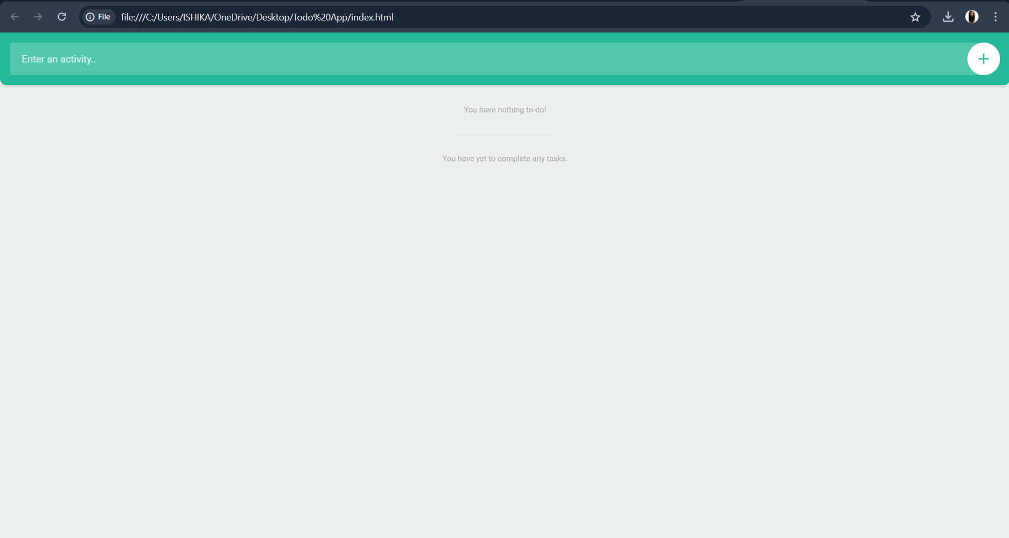

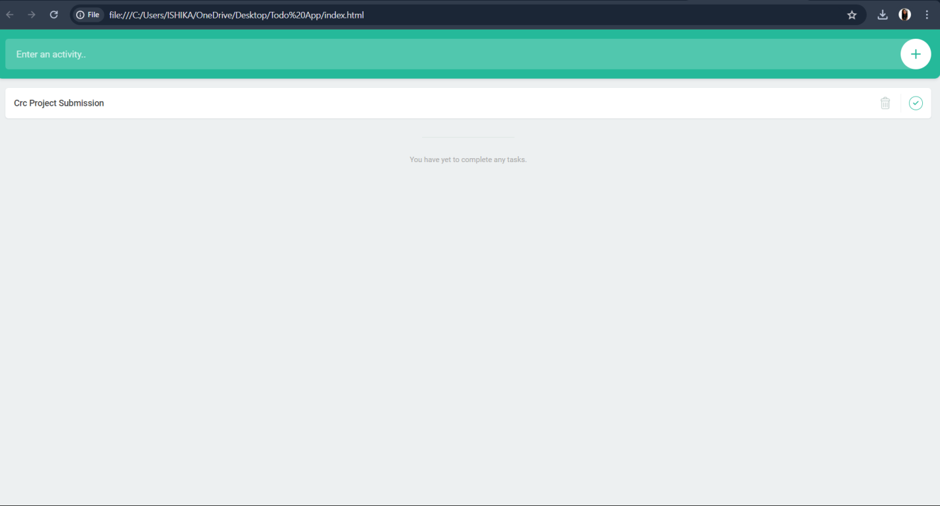

1. Snake Game :

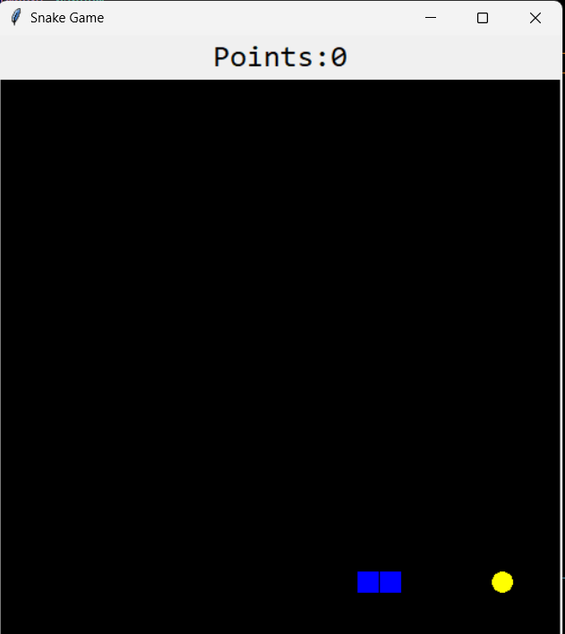

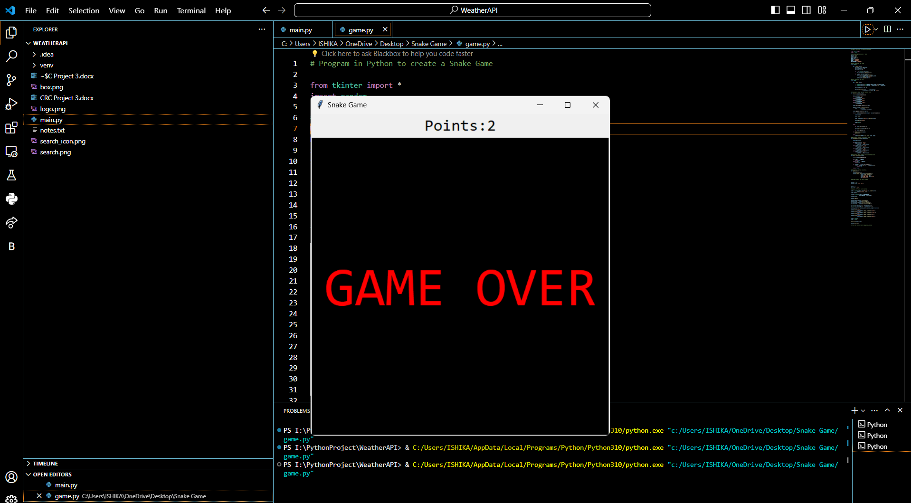

1. Weather Forecast App :

